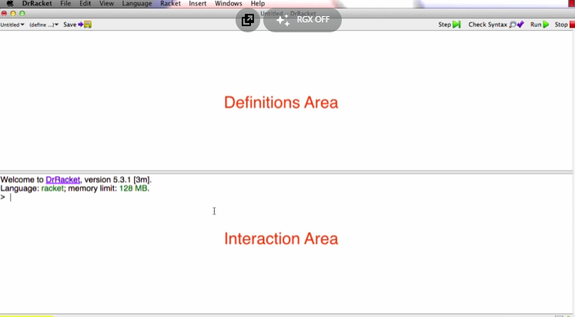

Simple arithmetic expression ->  ->  ->

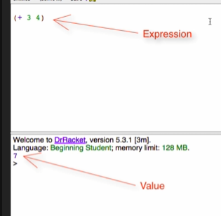

Racket evaluates expressions to produce values

To form an Expression:

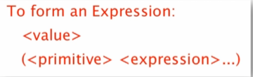

Commenting with semi-colons

* Racket ignores everything on a line after the first semi-colon

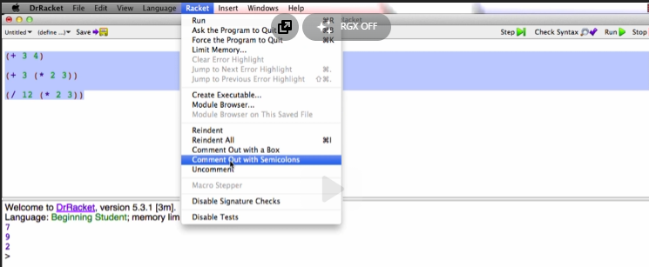

sqr (n^2) & sqrt (n^1/2)

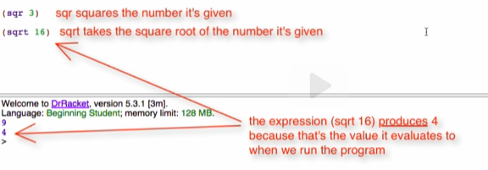

Comment Box

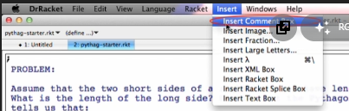

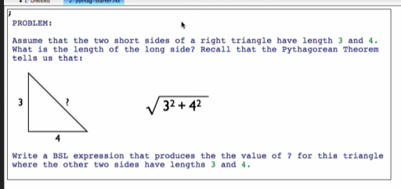

* Everything in the box is a comment
* You can also put images inside the box